**RETAIL FINANCIAL ANALYSIS REPORT(2013-2014)**

**1) COUNTRY WISE HIGHEST SELLING PRODUCT :**

SELECT

Country,

ProductName,sales,

units_sold

FROM(

SELECT a.*,

ROW_NUMBER() OVER(PARTITION BY country ORDER BY sales DESC) as rn

FROM(

SELECT Country,

ProductName,

MAX(Sales) as sales,

SUM(Units_Sold) as units_sold

FROM[dbo].[Finance]

GROUP BY Country,ProductName

)a

)b

where rn=1 ORDER BY sales desc;

**RESULT:**

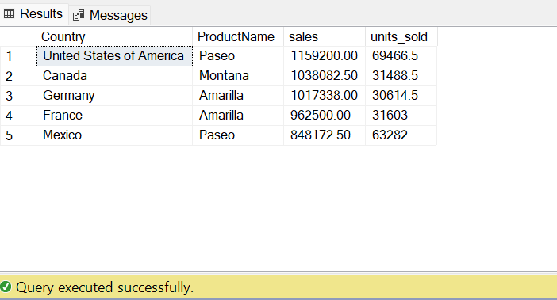

**2) SEGMENT WISE HIGHEST SELLING PRODUCT :**

SELECT Segment,

ProductName,

sales,

units_sold

FROM(

SELECT a.*,

ROW_NUMBER() OVER(PARTITION BY country ORDER BY sales DESC) as rn

FROM(

SELECT Segment,

ProductName,

MAX(Sales) as sales,

SUM(Units_Sold) as units_sold

FROM[dbo].[Finance]

GROUP BY Segment,ProductName

)a

)b

where rn=1 ORDER BY sales desc;

**RESULT:**

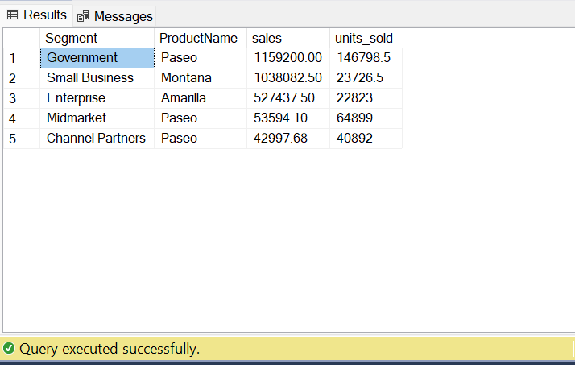

**3) HIGHEST TO LOWEST PROFITED PRODUCTS FOR A YEAR 2013**

/*YEAR PROCEDURE*/

CREATE Procedure yearly_sales @year int

AS

SELECT

ProductName,

sum(Profit)as profit,

Year

FROM [dbo].[Finance]

WHERE Year=@year

GROUP BY ProductName,

Year ORDER BY profit DESC;

GO

/*2013 Highest to Lowest profitted Products*/

EXEC yearly_sales 2013;

**RESULT:**

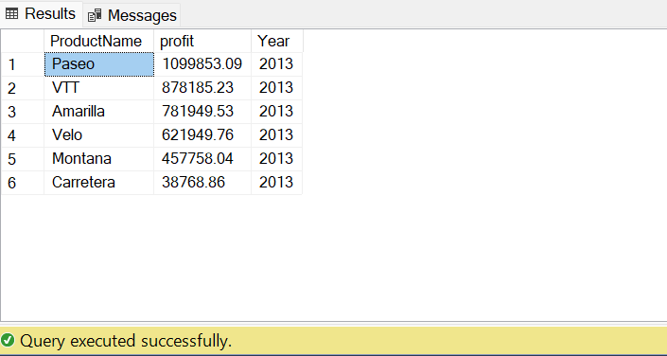

**4) HIGHEST TO LOWEST PROFITED PRODUCTS FOR A YEAR 2014**

/*YEAR PROCEDURE*/

CREATE Procedure yearly_sales @year int

AS

SELECT

ProductName,

sum(Profit)as profit,

Year

FROM [dbo].[Finance]

WHERE Year=@year

GROUP BY ProductName,

Year ORDER BY profit DESC;

GO

/*2014 Highest to Lowest profitted Products*/

EXEC yearly_sales 2014;

**RESULT:**

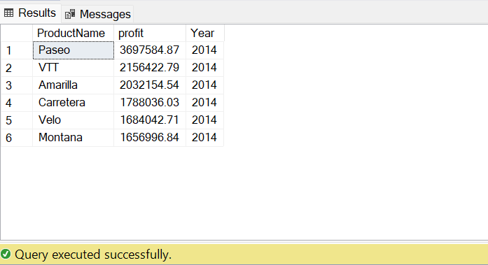

**5) BEST SELLING PRODUCT FOR YEARS 2013 TO 2014**

SELECT TOP 1

ProductName,

SUM(Sales) AS Sales,

SUM(Profit) AS Profit,

SUM(Discounts) AS Discounts,

SUM(Units_sold) AS units_sold,

Year

FROM [dbo].[Finance]

GROUP BY ProductName,

Year

ORDER BY Sales DESC;

**RESULT:**

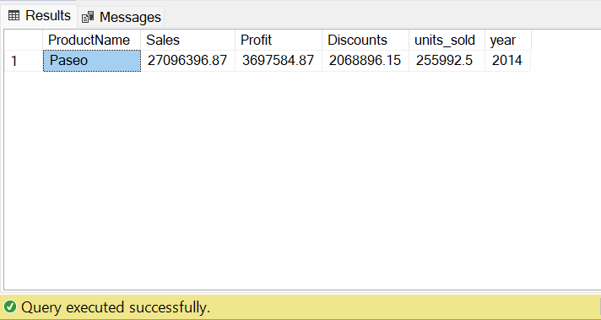

**6) LEAST SELLING PRODUCT FOR YEARS 2013-2014**

SELECT TOP 1

ProductName,

SUM(Sales) AS Sales,

SUM(Profit) AS Profit,

SUM(Discounts) AS Discounts,

SUM(Units_sold) AS units_sold,

Year

FROM [dbo].[Finance]

GROUP BY ProductName,

Year

ORDER BY Sales ASC;

**RESULT:**

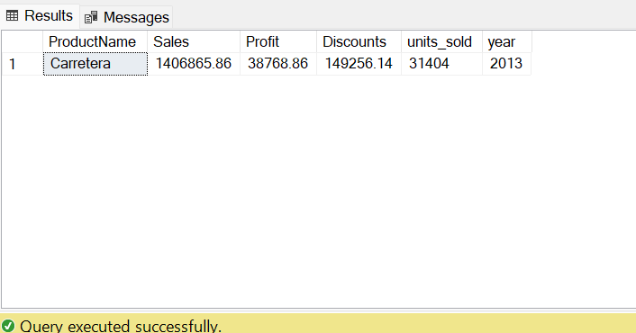

**7) PEAK SALES PERIOD OF EACH PRODUCT**

SELECT

ProductName,

Sales1,

Date

FROM

(

SELECT a.*,

ROW_NUMBER() OVER(PARTITION BY ProductName ORDER BY Sales1 DESC) AS rn FROM

(

SELECT ProductName,

MAX(Sales) OVER(PARTITION BY ProductName,Date) AS Sales1,

Date

FROM [dbo].[Finance]

)a

)b where rn=1;

**RESULT:**

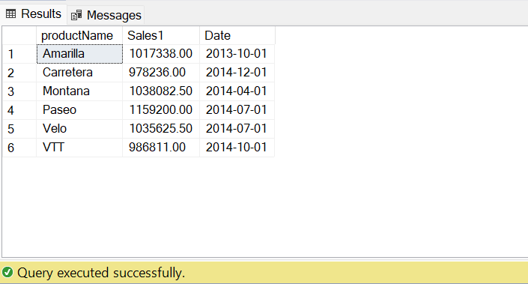

**8) MONTH WISE TOP PERFORMED PRODUCT FOR A YEAR 2014**

WITH Monthlysales AS (

SELECT

Year,

Month_Number,

ProductName,

SUM(Sales) AS total_sales

FROM [dbo].[Finance]

WHERE

year = 2014

GROUP BY

Year,

Month_Number,

ProductName

),

top_Product AS (

SELECT

Year,

Month_Number,

ProductName,

total_sales,

RANK() OVER (PARTITION BY Year, Month_Number ORDER BY total_sales DESC) AS Product_rank

FROM

Monthlysales

)

SELECT

Year,

Month_Number,

ProductName,

total_sales

FROM

top_Product

WHERE

product_rank = 1

ORDER BY

Year,

Month_Number;

**RESULT:**

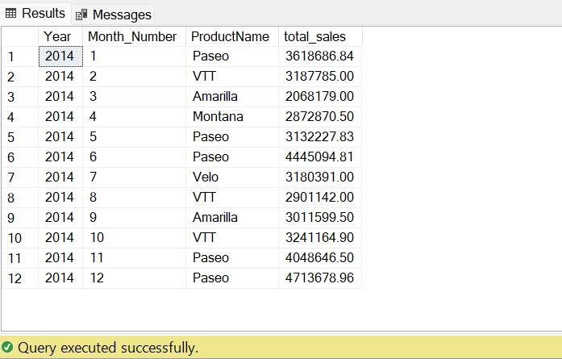

**9) IDENTIFYING THE PRODUCTS AND MONTHS THAT HAVE HAD A DECREASE IN SALES PRICE FROM THE PREVIOUS MONTH IN A YEAR 2013**

WITH price_change

AS

(

SELECT

ProductName,

Year,

Month_Name,

SUM(Sales) as montly_sales,

LAG(SUM(Sales))

OVER (PARTITION BY ProductName ORDER BY Year,Month_Name DESC)

AS

previous_sales_price

FROM [dbo].[Finance]

GROUP BY ProductName,

Year,

Month_Name

)

SELECT

ProductName,

Year,

Month_Name,

montly_sales

FROM

Price_change

WHERE

montly_sales<previous_sales_price AND Year=2013

**RESULT:**

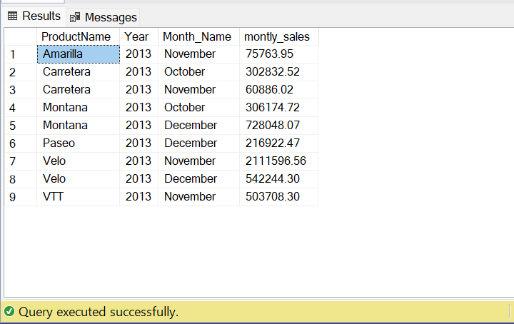

**10) CONTRIBUTION PERCENTAGE OF EACH PRODUCT IN THE SALES FOR YEAR 2014**

WITH Total_sales

AS

(

SELECT

Year,

SUM(Sales) AS total_sales

FROM [dbo].[Finance]

WHERE Year=2014

GROUP BY Year

),

Total_product_sales

AS

(

SELECT

ProductName,

SUM(Sales) AS Product_sales

FROM [dbo].[Finance]

WHERE Year=2014

GROUP BY ProductName

)

SELECT

ProductName,

ROUND((product_sales/Total_sales.total_sales)*100,2) AS percentage

FROM Total_product_sales

CROSS JOIN Total_sales;

**RESULT:**

